# ### 1. s1s2 trans count (within & between PI), succession broad

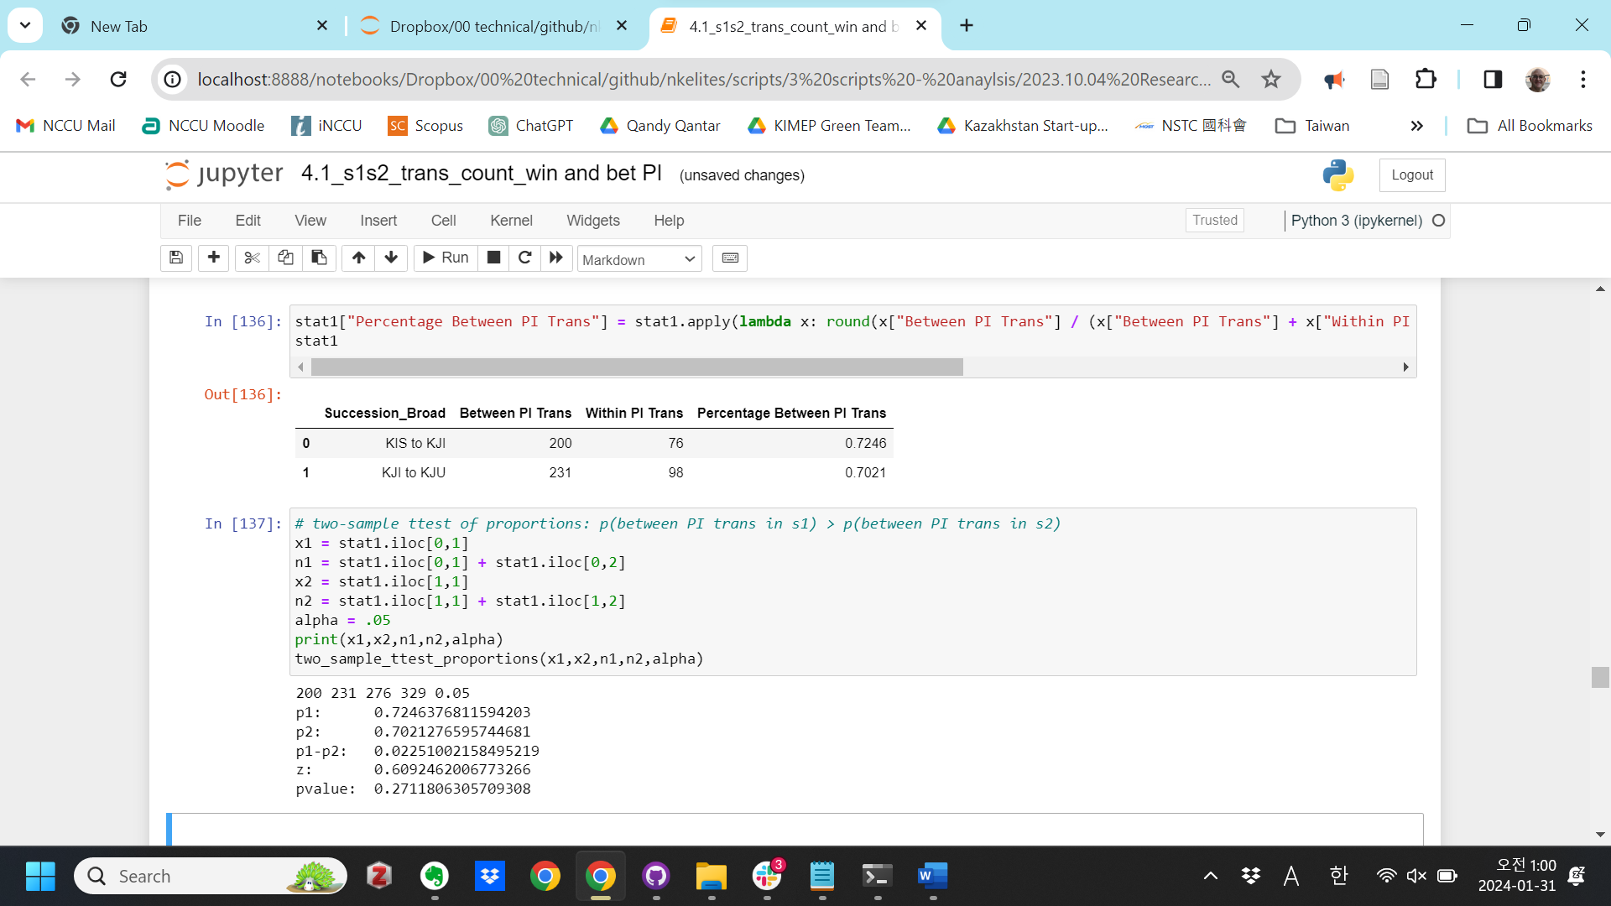

# ### 2. s1s2 trans count (within & between PI), succession narrow

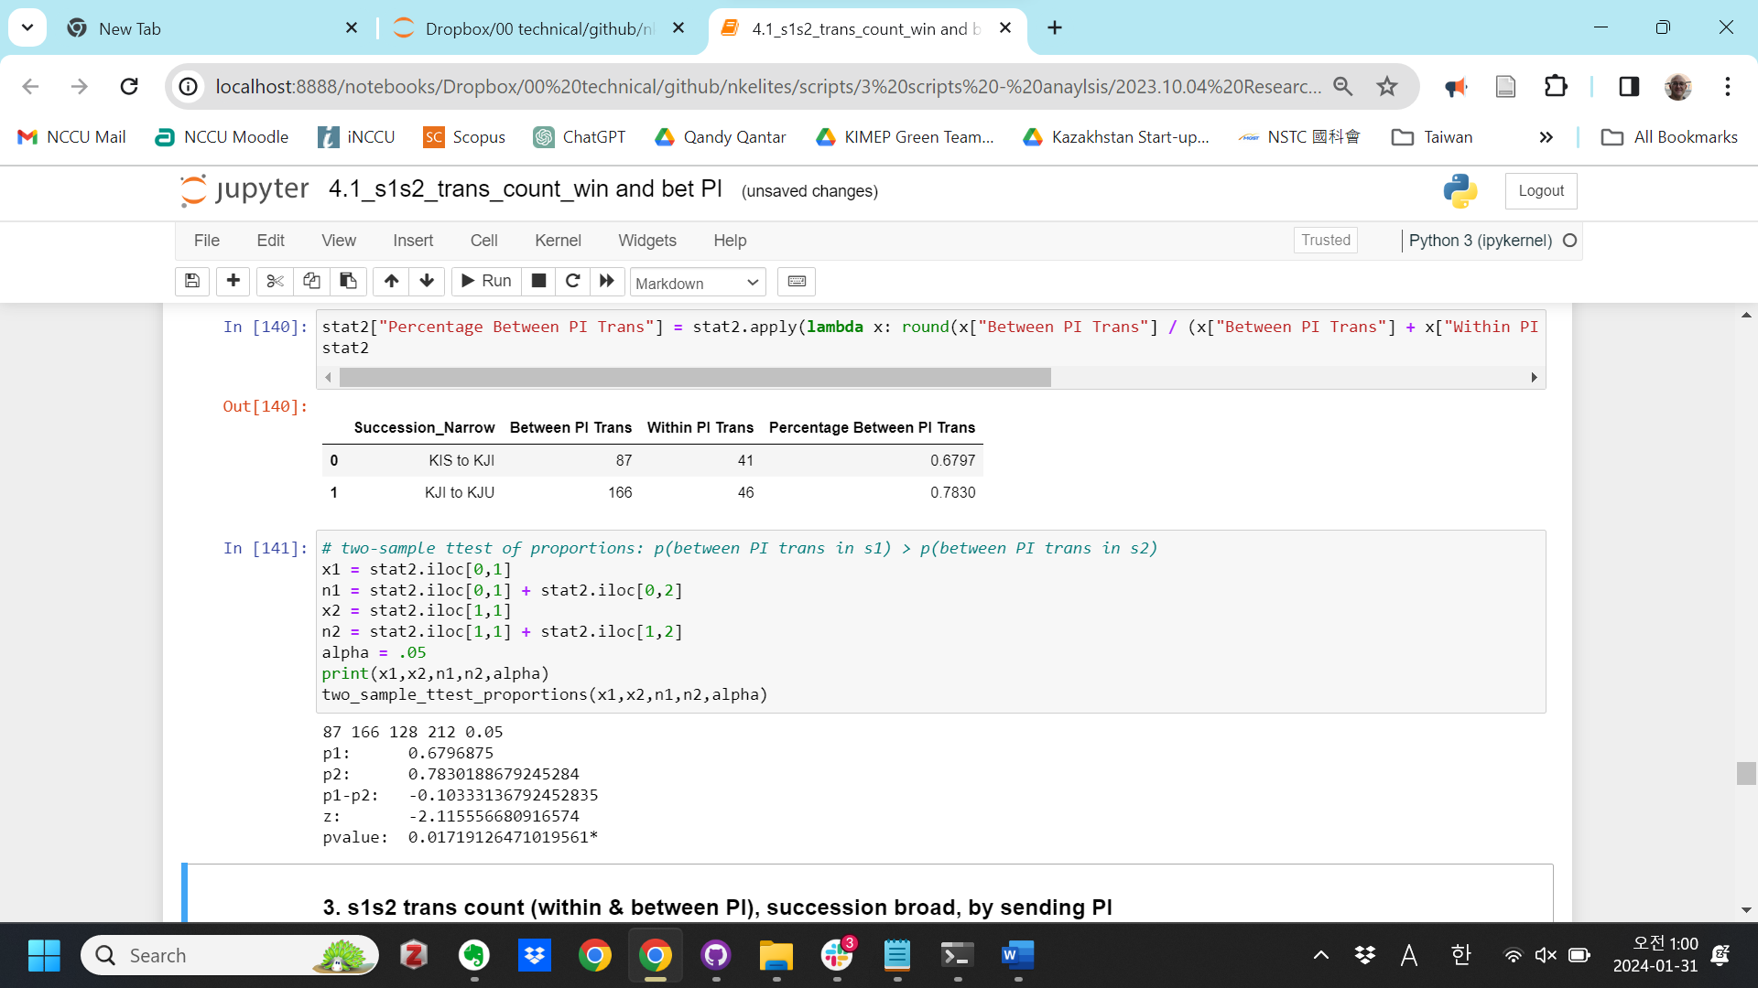

# ### 3. s1s2 trans count (within & between PI), succession broad, by sending PI

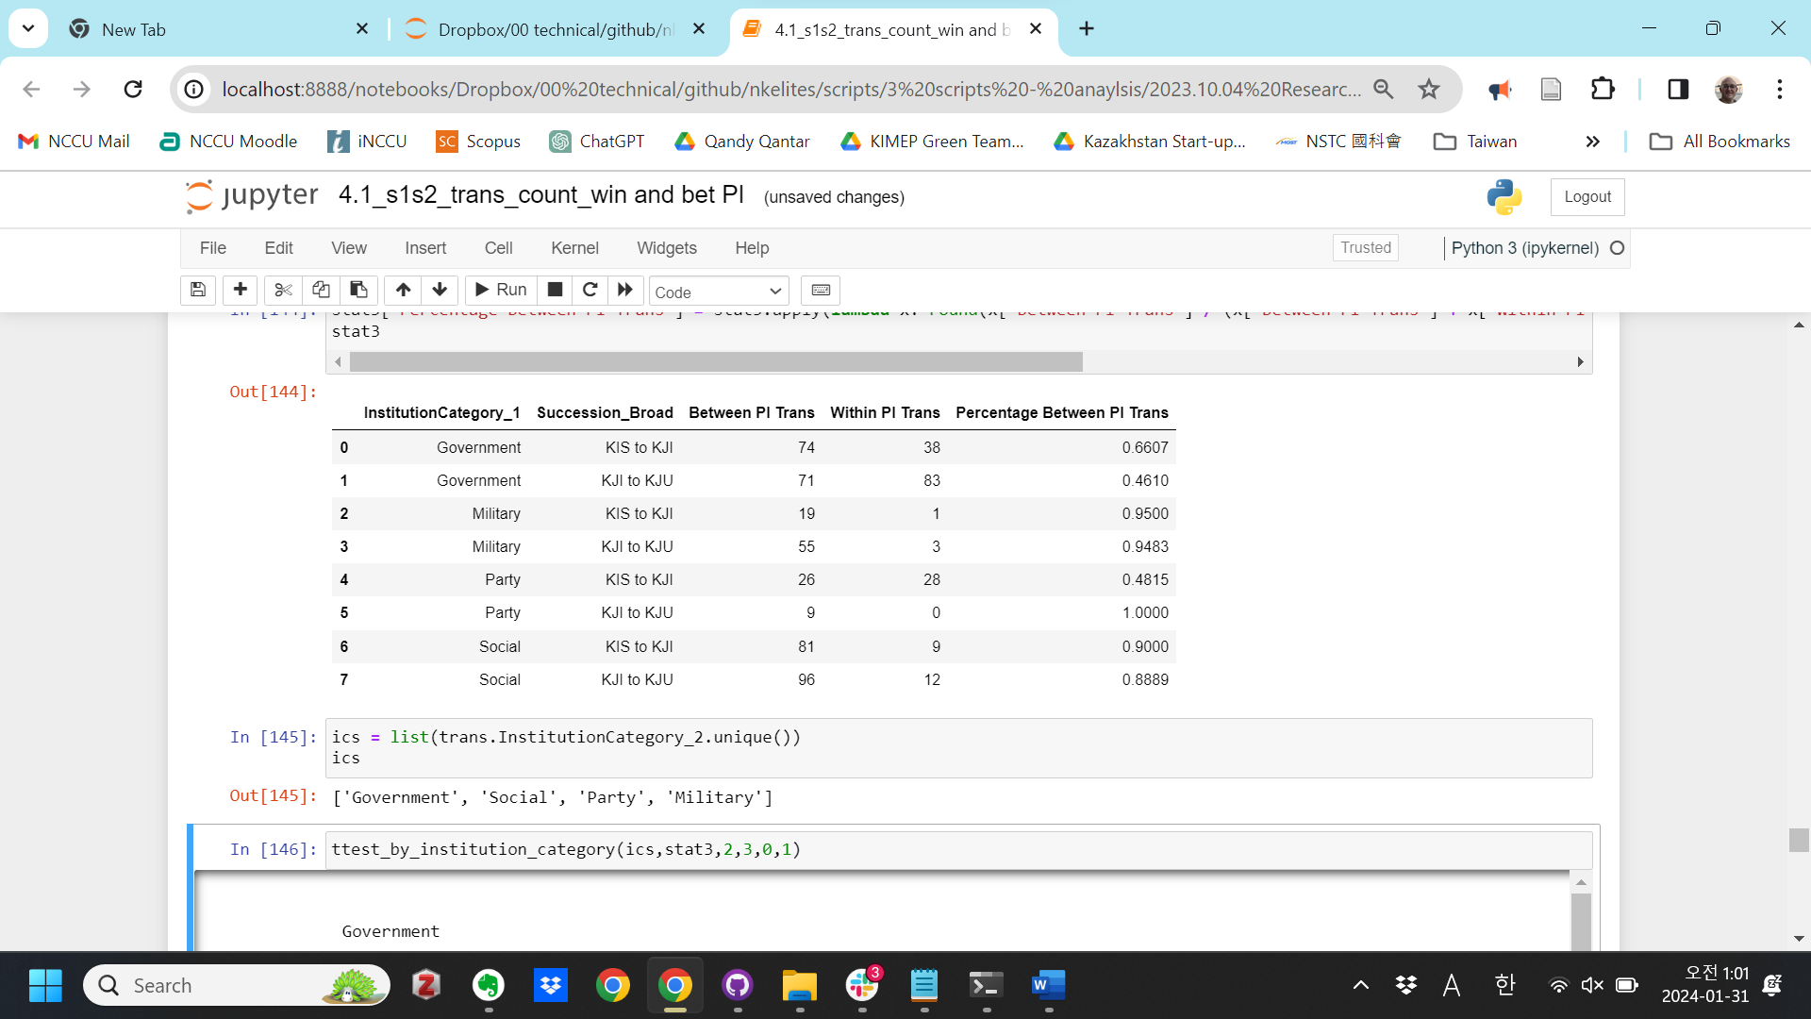

Government

74 71 112 154 0.05

p1: 0.6607142857142857

p2: 0.461038961038961

p1-p2: 0.19967532467532467

z: 3.228924595009941

pvalue: 0.0006212832650408506***

Social

81 96 90 108 0.05

p1: 0.9

p2: 0.8888888888888888

p1-p2: 0.011111111111111183

z: 0.2528290295037481

pvalue: 0.40020016700650896

Party

26 9 54 9 0.05

p1: 0.48148148148148145

p2: 1.0

p1-p2: -0.5185185185185186

z: -2.8982753492378883

pvalue: 0.0018761050504368937**

Military

19 55 20 58 0.05

p1: 0.95

p2: 0.9482758620689655

p1-p2: 0.0017241379310344307

z: 0.030144108677776116

pvalue: 0.4879760615309169

# ### 4. s1s2 trans count (within & between PI), succession narrow, by sending PI

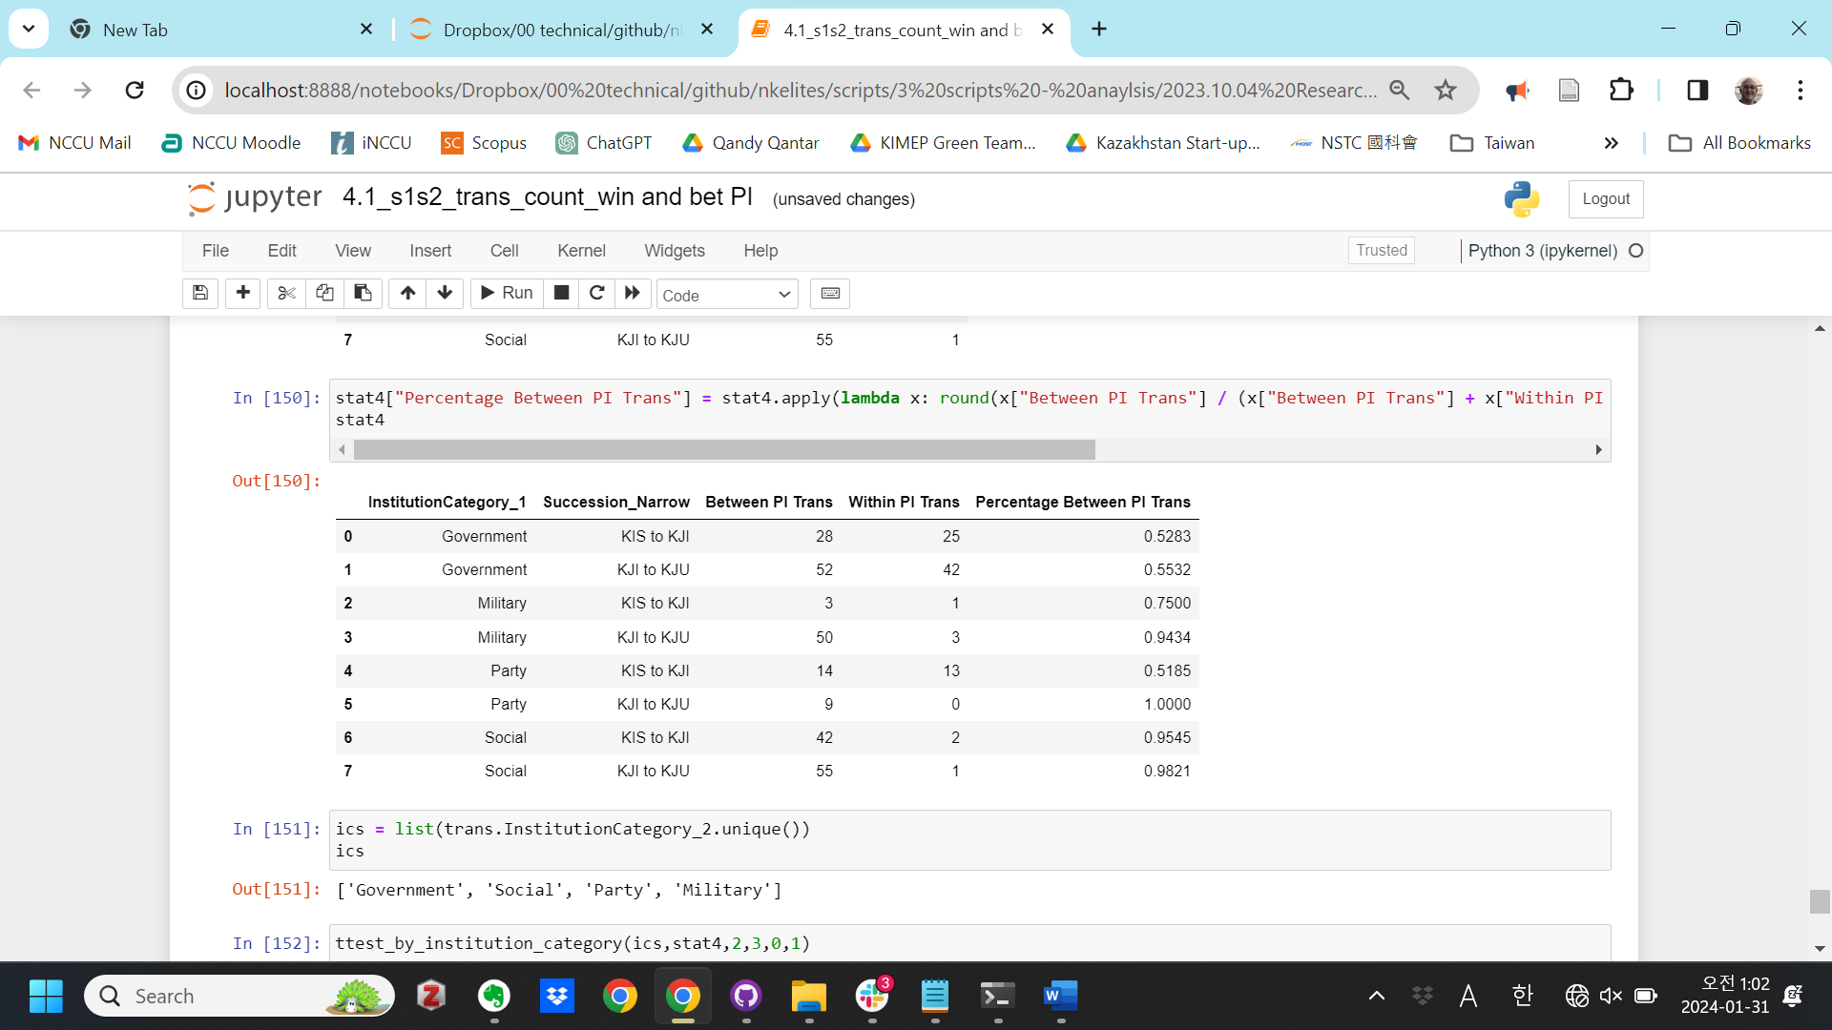

Government

28 52 53 94 0.05

p1: 0.5283018867924528

p2: 0.5531914893617021

p1-p2: -0.024889602569249325

z: -0.2909350839375055

pvalue: 0.38555048411522264

Social

42 55 44 56 0.05

p1: 0.9545454545454546

p2: 0.9821428571428571

p1-p2: -0.02759740259740251

z: -0.8030490385336473

pvalue: 0.21097319562964278

Party

14 9 27 9 0.05

p1: 0.5185185185185185

p2: 1.0

p1-p2: -0.4814814814814815

z: -2.6043441968472933

pvalue: 0.004602513104475459**

Military

3 50 4 53 0.05

p1: 0.75

p2: 0.9433962264150944

p1-p2: -0.19339622641509435

z: -1.460109489840098

pvalue: 0.07212999245351459